**TABLES:**

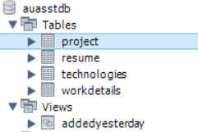

**TABLE SCHEMAS:**

**PROJECT:**

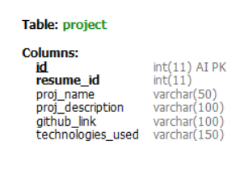

**(resume_id foreign key references pk of resume table)**

**RESUME:**

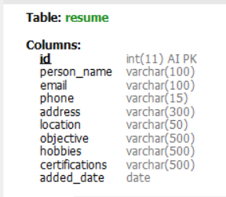

**(resume_id foreign key references pk of resume table)**

**WORK DETAILS:**

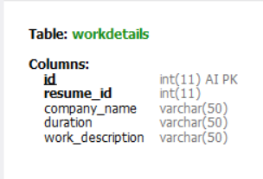

**(resume_id foreign key references pk of resume table)**

**TECHNOLOGIES:**

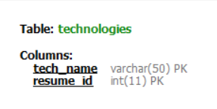

**(resume_id foreign key references pk of resume table)**

1. **CREATING TABLES**

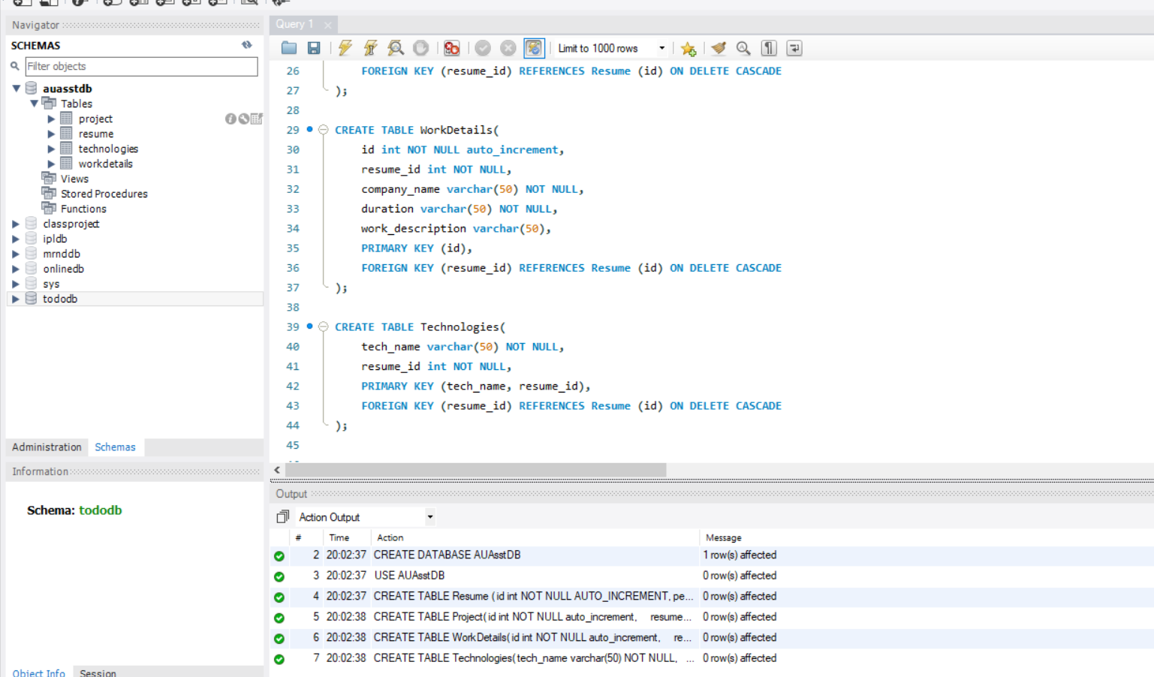

1. **INSERTING INTO DB**

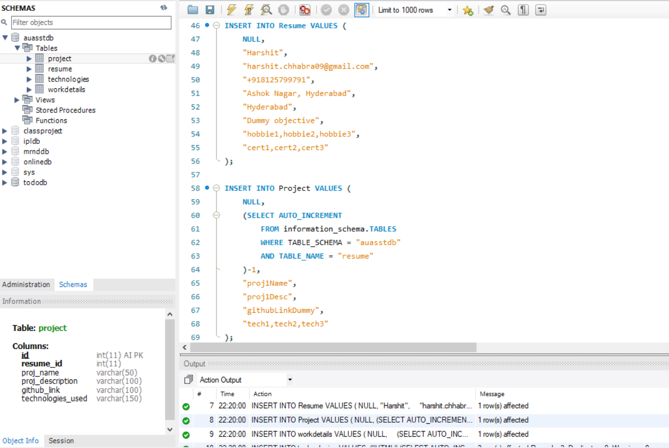

**\*\* BULK ENTRY OF DATA WAS DONE WITH DUMMY DATA (STATIC INPUTS)**

**\*\* QUERY FOR THE SAME CAN BE FOUND IN THE SQL SCRIPT**

**3.1 Get list of candidates based in ‘Hyderabad’ which were added to the system in the past 3 months.**

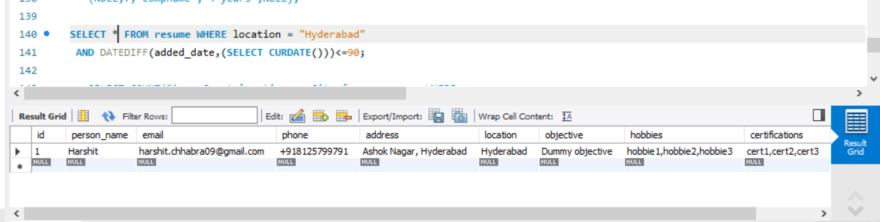

**3.2 Get count of candidates in all cities, who know Javascript and Html.**

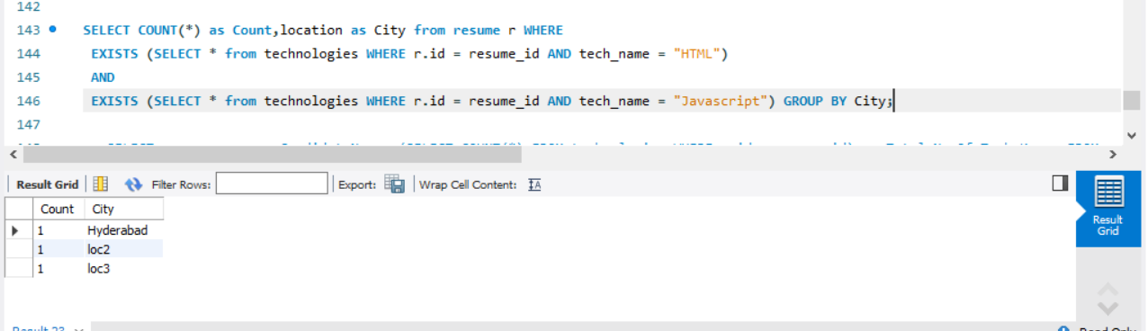

**3.3 Get list of all candidates sorted by “maximum number of technologies known to him/her”**

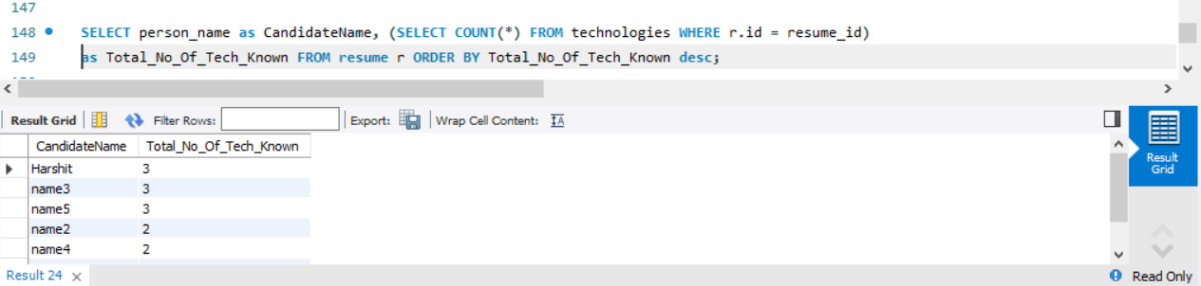

**3.4 Create a view that HR can query everyday to get the new candidates added previous day. (Include all necessary fields required by HR)**

